Squeak Race Track

1. Open navigator, click on the paint brush.
2. Make a race track using the following colors:
a. track black
b. outside green
c. inside light blue
3. Click on keep. Scroll click and then click on the menu handle (red button at top on left side).

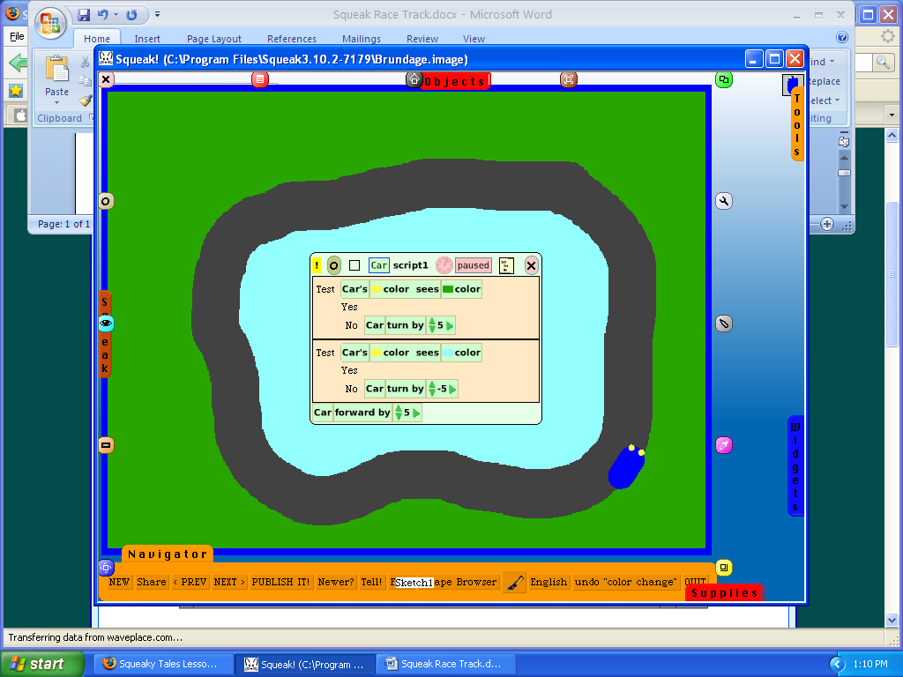

4. Select “resist being picked up”

5. Open navigator, click on the paint brush. Make car. The car must have two visible yellow headlights at the front of the car.

6. Resize the care if necessary so that it fits on your track. Place your car on the track. Open the viewer (eye). Pull the forward by 5 script to the center of the racetrack.

7. Add two test boxes above the script forward by 5. Then add car turn by 5 before the NO.

8. On the view click on script and then tests.
tests

9. Drag the script color sees beside the word Test in each box. In the first test box click in the first color box. Using the eye dropper tool click on your yellow headlights. Click in the second color box. Click outside of the race track.
Click in the second test box click in the first color box. Using the eye dropper tool click on your yellow headlights. Click in the second color box. Click inside of the race track.

It should look like the example below. Click your timer and see if the car will drive on the track.

